**Module 15) HTML in Full Stack**

1. HTML Basics

Question 1: Define HTML. What is the purpose of HTML in web development?

Answer: HTML stands for Hyper Text Markup Language and it is a markup language (not a programming language) developed by Tim Berners Lee. It is a standard language that helps in building the basic blocks of a webpage or a website. In HTML, “Hyper Text” stands for “text within text” which means a text that has a link within it, is a hypertext. Whenever a given link in HTML is clicked, it will take you to another web page, website or to some form of media like an image, an audio, or a video. Furthermore, “Markup Language” in HTML, means a type of computer language that is used to apply layout and formatting conventions to a text document, and is achieved by using tags, elements, and attributes. In summary, HTML provides the basic structure of web pages, including elements like headings, paragraphs, links, images, tables, and more. HTML uses a system of tags to define how these elements should be displayed on the page.

**Main purposes of HTML in web development are as follows**:

1. **Laying out the structure**: HTML defines the structure of web pages by using tags to organize text, images, links, videos, forms, and other elements. For example, it uses tags like <h1> for headings, <p> for paragraphs, and <img> for images.
2. **Creating Links**: HTML makes it possible to create hyperlinks using the <a> tag, enabling users to navigate between different web pages, websites, and multimedia. This is fundamental for browsing the web.
3. **Embedding Multimedia**: HTML allows you to embed images, videos, and audio elements on your web pages using tags like <img>, <video>, and <audio>. This enriches the user experience with visual and audio content.
4. **Providing Semantics**: HTML provides a semantic structure that helps search engines and assistive technologies understand the content of a page. Tags like <header>, <footer>, <article>, and <section> give meaning to content, improving accessibility and SEO (Search Engine Optimization).
5. **Forms and User Input**: HTML allows the creation of forms with fields like text boxes, checkboxes, and buttons using tags such as <form>, <input>, and <button>. This is key for collecting user data, such as in login forms or surveys.

In short, HTML lays out the foundation of any website, providing the basic structure and content that other technologies like CSS (for design) and JavaScript (for interactivity) build upon.

Question 2: Explain the basic structure of an HTML document. Identify the mandatory tags   
and their purposes.

Answer: The basic structure of an HTML document is composed of several key elements that define the content and structure of the webpage. These elements are placed in a specific order to ensure the page is correctly rendered in a web browser.

Here is the basic structure of an HTML document:  
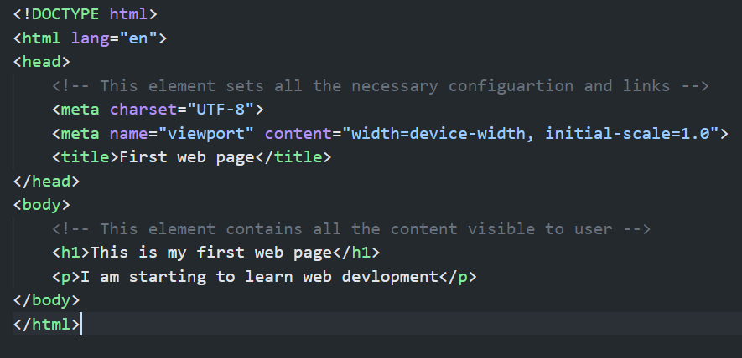

**Key Mandatory Tags and Their Purposes:**

1. **<!DOCTYPE html>**:
   * **Purpose**: Declares the document type and version of HTML. In this case, it specifies that the document is using HTML5.
   * **Importance**: It ensures that all the browser knows how to render the page correctly.
2. **<html>**:
   * **Purpose**: The root element that contains all the HTML code of the webpage.
   * **Importance**: It encapsulates the entire HTML content and signals the start and end of the HTML document.
3. **<head>**:
   * **Purpose**: Contains metadata about the document, such as the title of the page, links to stylesheets, logo, character encoding, and other information not visible to the user.
   * **Importance**: It provides essential information about the document, though its content is not directly rendered on the webpage.

**Important Tags Inside <head>:**

* + - meta charset="UTF-8">: Specifies the character encoding (UTF-8 ensures that most characters from all languages are supported).
    - <meta name="viewport" content="width=device-width, initial-scale=1.0">: Used for creating web pages that are responsive enough to be displayed across various devices like mobiles, tablets and PCs.
    - <title>: Sets the title of the document, which appears in the browser tab or title bar.

1. **<body>**:
   * **Purpose**: Contains all the visible content of the webpage, such as text, images, links, etc.
   * **Importance**: It is where all the content the user interacts with is placed. Without the <body> tag, the content would not be displayed on the webpage.

Question 3: What is the difference between block-level elements and inline elements in   
HTML. Provide examples of each.

Answer: In HTML, elements are categorized as either **block-level** or **inline** based on how they behave within the layout of a webpage. The difference between these two types of elements lies in how they are displayed on the page and how they interact with other elements around them.  
  
**Block-Level Elements:**Block-level elements take up the full width available (by default) and create a new "block" or line. They start on a new line and extend the full width of their container. They can contain other block-level elements or inline elements inside them.  
  
**Inline Elements:**Inline elements only take up as much width as necessary to fit their content. They do not cause line breaks and are displayed within the flow of surrounding content, meaning they sit next to other inline elements.

**Main Differences:**

|  |  |  |
| --- | --- | --- |
| Aspect | Block-Level Elements | Inline Elements |
| Layout Behaviour | Take up the full width of their container. | Only take up as much space as needed by the content. |
| New Line | Always start on a new line. | Do not start a new line. |
| Can Contain | Can contain both block-level and inline elements. | Can only contain inline elements or text. |
| Examples | <div>, <p>, <h1>, <br> | <b>, <i>, <span>, <markup> |

Question 4: Discuss the role of semantic HTML. Why is it important for accessibility and SEO.  
Provide examples of semantic elements.

Answer: **Semantic HTML** refers to the use of HTML elements that clearly describe their meaning in both the structure and content of a webpage. Unlike non-semantic elements (like <div> or <span>), which are generic and do not provide much information about their contents, **semantic elements** clearly convey the type of content they contain and its role on the page. This helps browsers, developers, and search engines understand the structure and content of a webpage more effectively.

**Importance of Semantic HTML for Accessibility and SEO**

**1. Accessibility**

* **Improves Screen Reader Compatibility**: Semantic HTML ensures that assistive technologies, like screen readers used by visually impaired users, can better interpret and navigate the content. For example, using <header>, <nav>, and <main> tags help screen readers identify the different sections of a page, making it easier for users to find and understand the content.
* **Improves Keyboard Navigation**: Semantic elements help create a more logical flow for keyboard-only navigation, making it easier for users who cannot use a mouse to move through the content.

**2. SEO (Search Engine Optimization)**

* **Search Engine Crawling and Ranking**: Semantic HTML provides search engines with clear information about the content and its importance. For example, the <header> tag tells search engines that it contains the introductory part of the page, and the <article> tag signifies independent content that could be indexed as a separate unit. This helps search engines understand the page better and potentially improve its ranking.
* **Content Relevance and Structure**: Search engines prioritize content marked with semantic tags (like <article>, <section>, <h1>) over generic tags (like <div>), as they help identify the main content, headings, and sections. This means that well-structured, semantic HTML can increase a webpage's relevance and help it rank higher for specific search queries.

**Examples of Semantic Elements**

1. **<header>**: Represents the introductory section of a page or a section. It often contains a logo, navigation links, or introductory content.
2. **<nav>**: Defines a section of links for navigation. It is used for the primary navigation menus, helping both users and search engines recognize that the links inside are for navigating the site.
3. **<main>**: Represents the dominant content of the <body> of a document. There should be only one <main> element per page, and it helps both users and search engines identify the primary content.

2. HTML Forms

Question 1: What are HTML forms used for Describe the purpose of the input, textarea, select, and button elements.

Question 2: Explain the difference between the GET and POST methods in form submission. When should each be used?

Question 3: What is the purpose of the label element in a form, and how does it improve accessibility

3. HTML Tables

• Question 1 Explain the structure of an HTML table and the purpose of each of the following

elements table, tr, th, td, and thead.

• Question 2 What is the difference between colspan and rowspan in tables Provide

examples.

• Question 3 Why should tables be used sparingly for layout purposes What is a better

alternative